***Florida International University***

***School of Computing and Information Sciences***

**Feature**

**Document**

**User Story #897**

**Team Member:** April Perry

**Product Owner(s)​:** Gummi Traustason

**Mentor(s)​:** Masoud Sadjadi

**Instructor​:** Masoud Sadjadi

**User Story #897 --** “Refactor statistics page CODE”

* As a DEVELOPER, I would like to refactor the current statistics page’s code in order to comply with the new format of the Database introduced this Sprint, as well as integrate into the new dashboard layout, so that the statistics page can be accessed via the new dashboard and still display data as expected.

### Acceptance Criteria:

1. New dashboard is ready
2. New database layout can be queried

**Use Case**

1. “Refactor statistics page CODE”

Participating Actors: Developer

Entry Condition:

a. Developer has downloaded new SkillCourt App code from github with  
 new dashboard

b. Developer has logged into app as ‘test2’ in order to access the  
 database’s new ‘real' go-forward format/layout

Events Flow:

1. Link existing Stats page to new dashboard layout menu button
2. Alter the way the Database instance of games played for current use is queried
3. Change the way the accessed data is saved based on new data types
4. Change the way that data is used to populate the graphs (graphs only take data type float)
5. Format the timestamp to show readable date of x-axis’

### Use Case Diagram

**N/A**   
(since this is doing refactoring of code on a previously developed feature. See the original feature document from User Story #872 and User Story #896)

### Sequence Diagram

**N/A**  
(since this is doing refactoring of code on a previously developed feature. See the original feature document from User Story #872 and User Story #896)

### Class Diagram

**N/A**  
(since this is doing refactoring of code on a previously developed feature. See the original feature document from User Story #872 and User Story #896)

### Unit and Integration Testing

**Test Case 1**

○ *Purpose:* RE-Test the accuracy of the database retrieval for a player  
 that has saved game data

○ *Precondition:* View Statistics page

○ *Expected Result:* The graphs are still created with the correct data

○ *Actual Result:* Same as expected.

○  *Status:* **PASS**

**Test Case 2**

○ *Purpose:* Test the functionality of the new dashboard’s ‘Statistics’  
 menu button

○ *Precondition:* Click on ‘Statistics’ text in new side-view menu.

○ *Expected Result:* The stats page is displayed

○ *Actual Result:* Same as expected.

○  *Status:* **PASS**

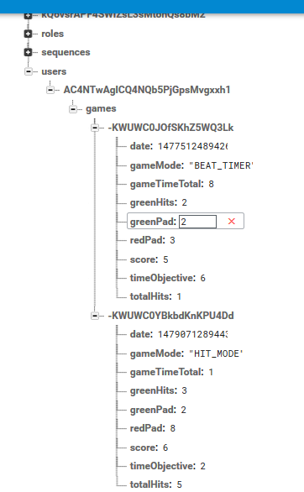

**Visual Diagram(s)**

*(🡪Snapshot of our NEW Database layout to compare to data below🡪)*

*(Snapshot below of our NEW Dashboard menu/Statistics button via Pedro)*

